|  |  |
| --- | --- |
| User name | User role |
| A | Account manager |
| B | Sales consultant |
| C | Senior IT systems admin |
| D | Software developer |
| E | User, Sales consultant |
| F | IT operations admin |

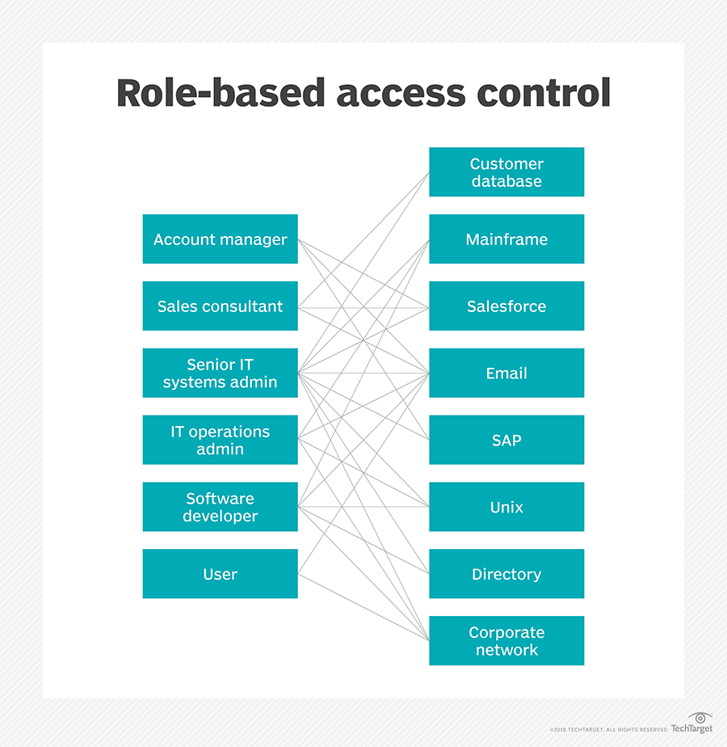

/user

|  |  |  |  |
| --- | --- | --- | --- |
| 方法名 |  |  |  |
|  |  |  |  |
|  |  |  |  |
|  |  |  |  |
|  |  |  |  |
|  |  |  |  |
|  |  |  |  |
|  |  |  |  |